|  |  |  |  |  |  |
| --- | --- | --- | --- | --- | --- |
| Date | 1-Dec-22 | | | Tester Name | Janette Paus |
| Environment | Penfax - Test 2 | | | Login used |  |
| Operating System | Windows | Version: 21H2 | Update Number: | | |
| Software Used | Select Software | Version: 107.0.1418.56 | Update Number: | | |
| Select Software | Version: | Update Number: | | |
| Application Release version | R22.4.1 | | | | |
| Test Case Title | E20.03a | | | | |
| Test Type | Regression | | | | |
| Test Scenario | Reverse a Member Deposit Same Day | | | | |
| Expected Results | Under Investments/Account activity it shows the reversal, units deposited and units removed due to reversal which is correct. The number of units are back to the amount before the deposit was entered. | | | | |
| Pass/Fail | Pass | | | JIRA# |  |

20.03a – Reverse Deposit Same Day

Step 1: Process Deposit

Search for any PEPP member (active or deferred) with funds still with PEPP

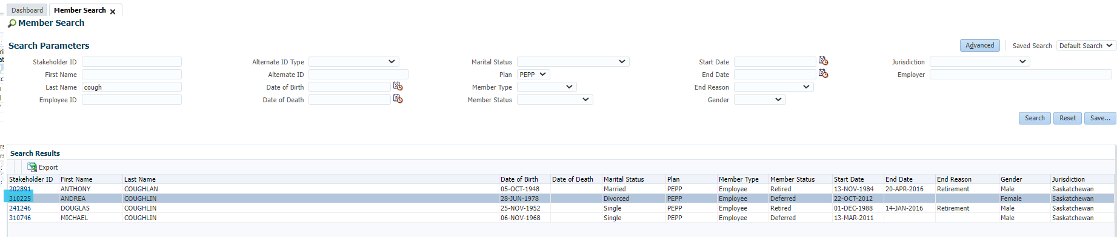

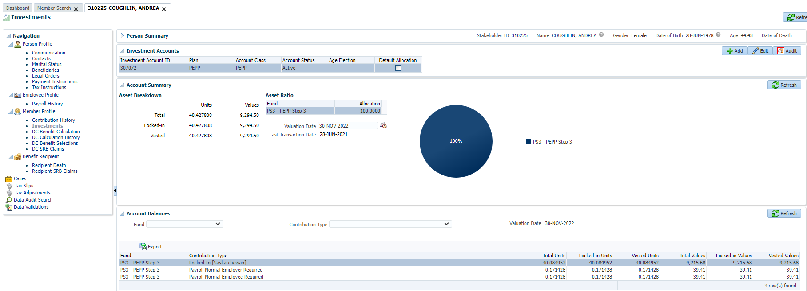

Deposit the funds under Member’s Contribution History

Funds deposited:

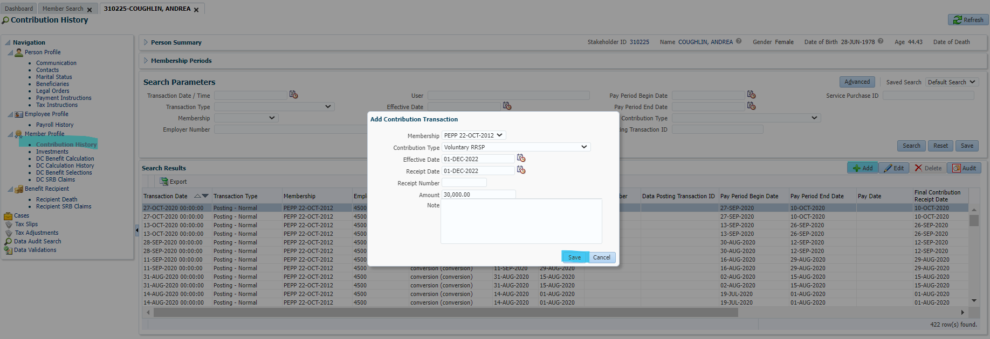

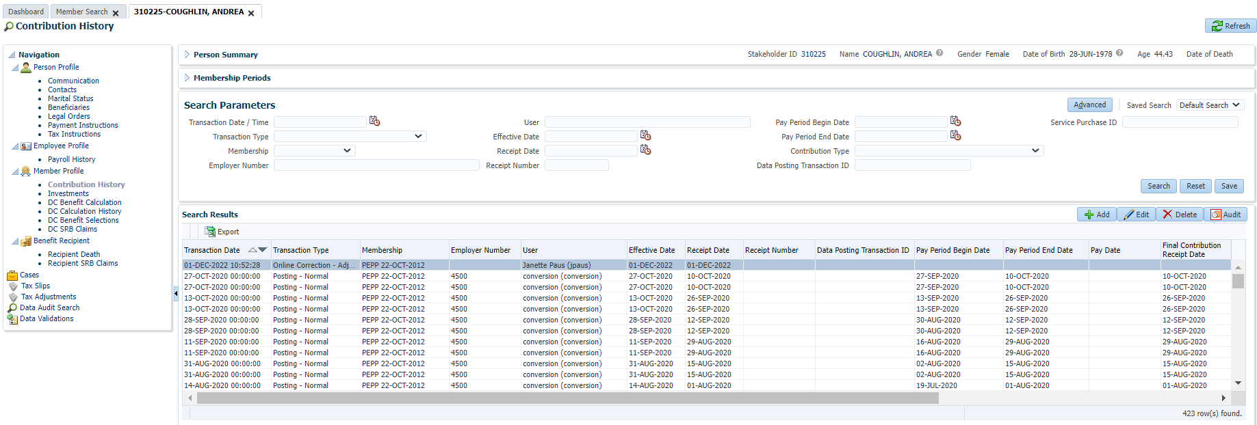

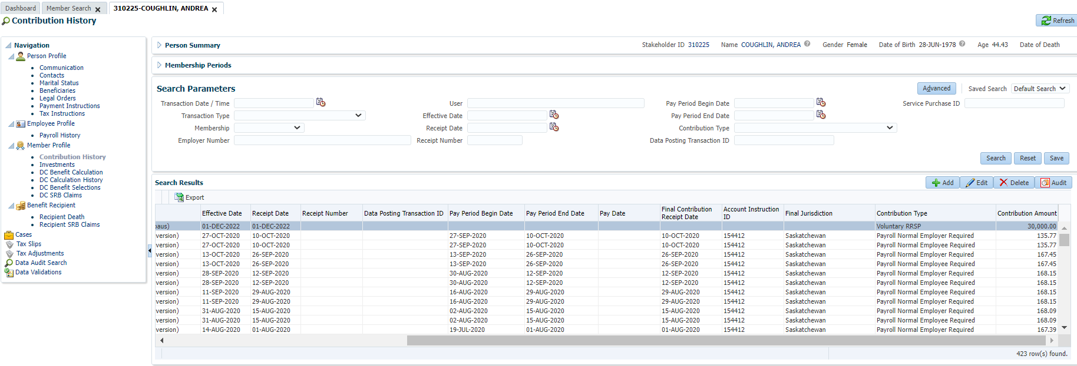

In Contribution History, highlight Transaction and click Delete

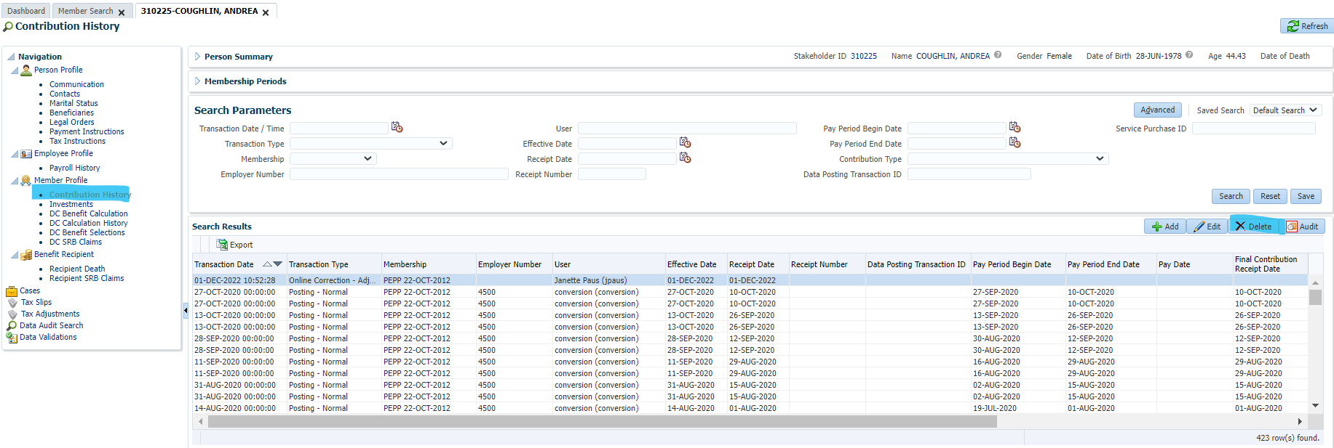

The transaction no longer shows under Contribution History:

